Instructions for Using the MAGI Job Aid, Manual Budget & Completing EIS Entry

Fill in the MAGI Medicaid Eligibility Questions Job Aid to determine if the individual meets non-financial criteria, and what HH & Income Counting Rules to use (Non-Filer, Tax Filer, or Tax Dependent)
Section A – If the person fails the Non-Financial Rules they are not eligible for MAGI Medicaid and will be referred to the FFM –Anyone that applies for Medicaid after January 1st and is not eligible will have a MAGI determination in EIS using CARC 5-55 or 5-56; if found ineligible for MAGI use the MAGI denial CARC of 5-59.
Section B – For EACH person listed on the application:
Determine if Non-Filer Household & Income counting rules apply – if so, complete section D of the job aid and complete the Income calculations
If the Non-Filer rules do not apply, complete section C of the job aid
Section C – This section is the Tax Filer or Tax Dependent Household and Income counting rules. This section will help you identify who is included in the Household for the individual, and the income to count for this individual’s eligibility
Section D – This section is where you document the countable income for the individual you are determining MAGI Medicaid eligibility for. While some guidance is contained on the job aid, it is best to refer to MAGI Medicaid Manual section 5710-3 818 for income policy.
Once you have determined the household status and whose income counts for EACH individual on the application proceed to the EXCEL MAGI Manual Budget and input this information to determine eligibility.

Upon opening the EXCEL MAGI Manual Budget for the first time (or subsequently re-opening it) you will need to choose to enable the Macros that automate the EXCEL worksheet.
1) Click on the Options button on the ribbon below the tool bar:
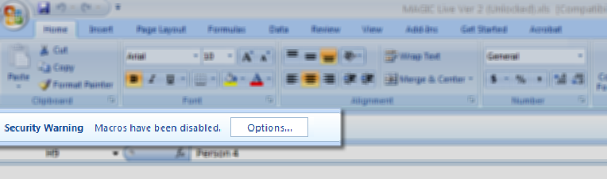
Once you click on the Options button a popup box will appear:
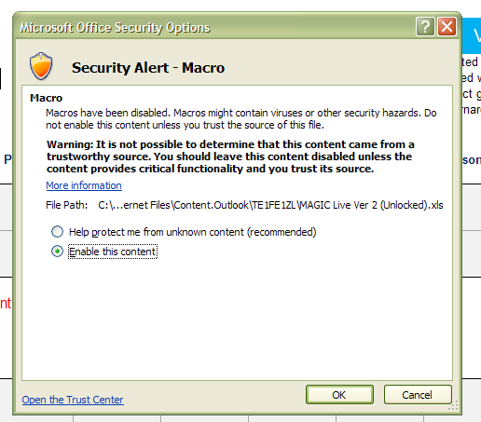
2) Choose the second option as shown above: Enable this content; then press OK to confirm your command.
3) Enter the names of the individuals on the application in Section A: Applicant Information. An edit will appear in red and a dropdown arrow will appear at the right corner of the box below the first individual’s name: 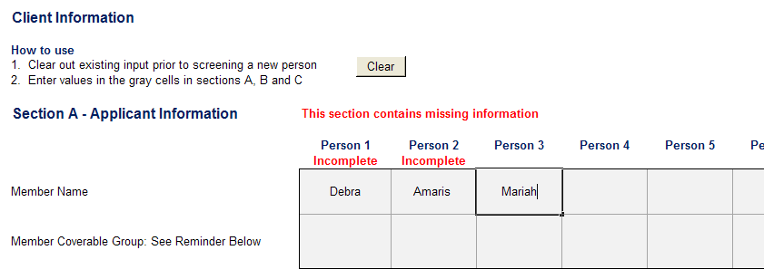
Notice you get a red edit with each name entered – that is to remind you to choose the
Member Coverage Group on the second line of this section.
4. Click on the drop-down arrow to choose the correct coverage group for each individual (once you complete the choice for Person 1, click in the box under the name of Person 2 to access the drop-down arrow for this person:
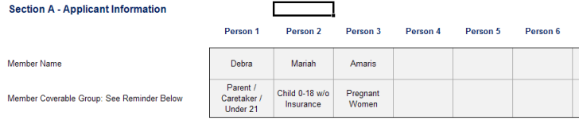
5. Continue on to Section B – MAGI Household Information – answer all the questions for each individual you entered in Section A. Click on the box below the name to access the drop-down menu and indicate the answer to the question Y on N: NOTE: In order to count the income of a tax dependent when the income is over the tax filing threshold enter “Y” in the field “Is the individual expected to be required to file taxes and code the income under the tax dependent.
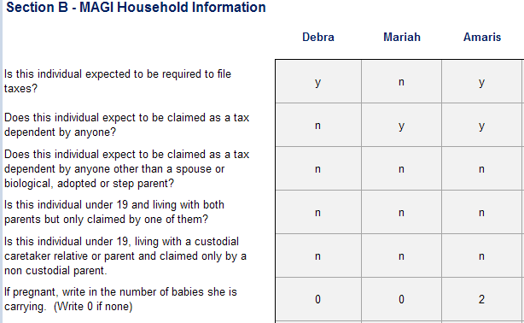
Enter the MONTHLY countable income (as determined in Section D of the MAGI Medicaid Eligibility Questions Job Aid) for each individual on the last line)
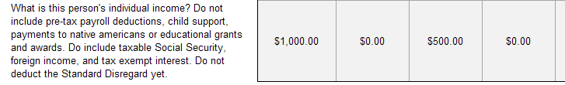
6. Once you have completed Sections A and B, click the Refresh button to show the relationships you need to complete on the Manual Budget Worksheet, Section C:
This will open up a table and you will be prompted to indicate Y for yes or leave the box blank if the answer is no.
PAY ATTENTION: this section of the manual budget is not about biological relationship as much as it is setting the MAGI HH & Income counting rules.
In the scenario below, Debra is both Amaris’s and Mariah’s mother; Mariah is age 18 Amaris is age 27. Mariah is Amaris’s sister, however Amaris is over age 19 - this means there is no MAGI relationship for Debra and Amaris, or for Amaris and Mariah:
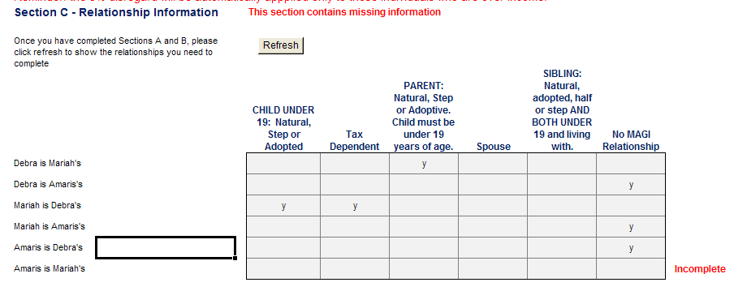
NOTE: There may be more than one Y for an individual. (For Example: Mariah is a Tax Dependent that is also a Child under 19: Natural, Step or Adopted – there should be a Y under both columns.) If you forget to fill in a necessary element for information previously entered on the worksheet you will see a red edit beside the line that is missing required information.
Once you have completed all the relationship tables available in the manual budget worksheet Section C – Relationship Information, you are ready to see the eligibility results.
Click on the second tab of the EXCEL MAGI Manual Budget workbook: Results:
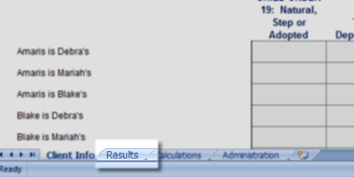
This will display a page of results that indicates who has passed the MAGI eligibility test and who has not.
There is a Results Summary that indicates who passed or the failed the eligibility test as well as what Coverable Group was selected and the size of the MAGI HH: 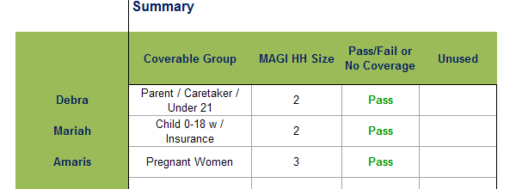
There are several tables on the RESULTS tab.

The next table is about HH Composition details – or who is in whose MAGI HH:
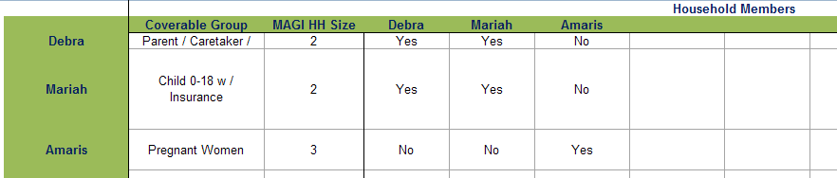
The second table on the RESULTS tab indicates who is included in each person’s household. In the example above Debra and Mariah is a household size of 2 even though we indicated in Section C of the Excel budget worksheet there was no MAGI relationship (because Mariah is over age 19) – this means the worksheet is programmed correctly to look at the information in Section C where we indicated that Mariah is Debra’s TAX DEPENDENT.
(Don’t over-think this! If you correctly indicate the information in Section C – the results will indicate who is in whose MAGI Medicaid household!)
Finally, there is a table that includes MAGI Income Details. This table will indicate who has countable income, and whose income counts for each individual MAGI Medicaid determination:
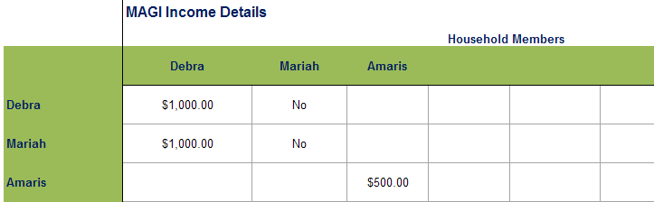
HINT: READ THE LINE ACROSS FROM THE NAME AT THE LEFT OF THE TABLE – Debra and Mariah’s income count for both Debra and Mariah; only Amaris’ money counts for her HH
Now that you have your results for each individual you are ready to go into EIS and enter the information so eligible individuals can receive MAGI Medicaid coverage.
Individuals that FAIL eligibility either because of income or no Coverage Category, will be referred to the FFM. Attempt to contact the client by phone. In any case, send a N011 with standard verbiage telling them to contact the FFM. Policy has developed macro verbiage to use with the N011.
Here is how you will code EIS for the case we have used in the example above:
1) PRINT a CLPM for EACH individual that has an open EIS case.
2) PRINT the CASS screen(s) on ANY open case and for EACH individual – this is extremely important to ensure you can maintain these cases properly after authorizing MAGI Medicaid.
3) Register a case in EIS using a NEW case number (even if there is prior ME history in EIS) and assigned to a CARC 5-55. Former Alaska Foster Care Children case CARC is 5-56.
4) Code the SEPA Screen.
Refer to the EXCEL Manual Budget Worksheet Results Summary when coding the SEPA. Code anyone that Passed eligibility “IN” on the SEPA. Code anyone that Failed, or has no MAGI Coverage Category “OU” on the SEPA.
In the scenario below, all 3 folks are coded “IN”:
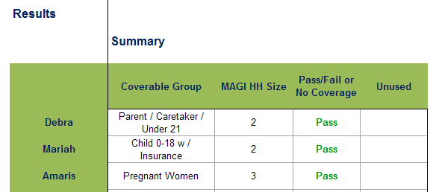
5) Continue coding EIS up to the first INCOME screen. If there is any income coded in EIS and any Income screen – enter a zero dollar amount. (Do not remove the Income Types or Subtypes – if you do, it will require a lot more work to maintain this case after you set up the MAGI ME case!)
6) Continue coding EIS to the MIBW screen. PAY ATTENTION here:
Children under age 19 use the KIDS CATEGORY – no SUBTYPE
Children age 19 to 21 use the FM CATEGORY with TO SUBTYPE
Former Alaska Foster Children over age 21 up to age 26:
use the FM CATEGORY with AF SUBTYPE and indicate this person is FR
** NOTE: REGARDLESS OF AGE- you must code the CSEA “EX” for this category **
CARETAKER RELATIVES over age 19 use the FM CATEGORY with AF
SUBTYPE
Pregnant women use PW CATEGORY with PR SUBTYPE - pregnant or
PB SUBTYPE - postpartum
Continue coding the MIBW screen to indicate BUDGET coding as appropriate (based on the MAGI HH Composition details of the Manual Budget Excel worksheet.
In the scenario we have been using, Amaris is pregnant with 2 babies:
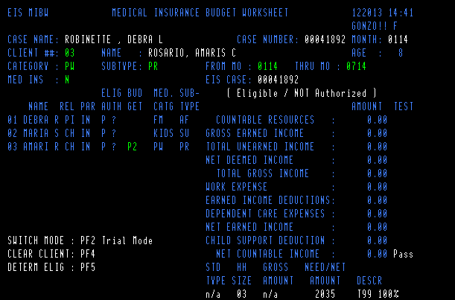
NOTE: Remember to ALWAYS answer the MED INS question on the MIBW screen
All income has been zeroed out. You will only be authorizing benefits for individuals that passed eligibility on the manual budget. You will have to compare the countable income to the appropriate income standard to ensure proper coding for the KIDS Subtype (SEE EIS MIBW coding for a case that has Children under Age 19 – page 9)
<NEXT> to the MIAU – authorize
<ENTER> through the MIED screen
<ENTER> through the MERE screen to the MERI screen.
Update the MERI screen with any TPR information for each individual.
<ENTER> to the NORE Screen and send the appropriate notice: N011. Policy has developed the standard verbiage to be used as a macro. The notice must contain each individual’s name and the specific category they are eligible to receive.
<APEM> Initialize this case into the current system month
Now this is important: You must go to any other open case (previously identified by printing a CLPM and CASS screen) and enter the correct INCOME information on the APA/FS/TA case in the MAGI benefit start month through the current system month (if they are not the same) and re-authorize benefits on the APA/FS/TA case. Once you have authorized benefits in the current system month be sure to check the CASS screen carefully and check the FSBH and/or TABH screens to ensure there has been no change to the benefit amount.
EIS MIBW coding for a case that has Children under Age 19
If you have children under the age of 19 that are eligible for MAGI Medicaid you will need to manipulate the MIBW screen to ensure they are in the appropriate income category – (remember the RESOURCE and INCOME screens have been zeroed out for the MAGI case).
Here is what to do:
First, remember to use the KIDS category (NO SUBTYPE) on the MIBW screen for children under age 19.
SCENARIO: Debra has applied for MAGI Medicaid for herself and her 3 year old child, tax-dependent Quade. Debra is required to file taxes. They have no insurance and Debra’s countable income for MAGI is $2900.

Question: Is Debra income eligible for MAGI-related Medicaid?
Let’s look at the Parent or Caretaker Relative MAGI Income Standards:
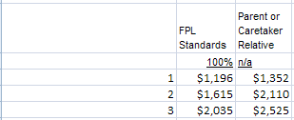
Debra’s countable income of $2900 exceeds the standard for Caretaker Relative HH size of 2 - $2110. She will fail eligibility on the Manual Budget therefore, she is coded OU on the SEPA.

Below is the MIBW first step for Quade:
<Code> CATEGORY KIDS
<Fill in the> FROM MO and THRU MO
<Answer the MED INS question>: Y or N
<Code the appropriate BUDGET coding>
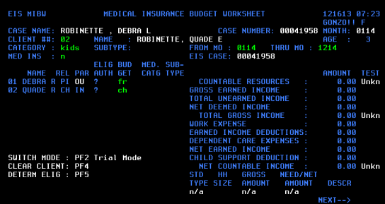
<PF5>
Because no income has been input for the MAGI Medicaid case, EIS will input a subtype of HC:
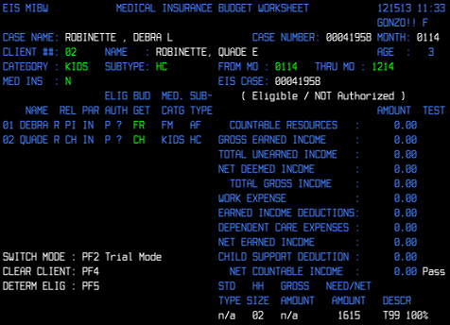

You must now input the correct SUBTYPE after looking at the countable income ($2900) and HH size (2) for Quade. Look at the KIDS SUBTYPE and MAGI INCOME Job Aid below and choose the correct SUBTYPE Code:
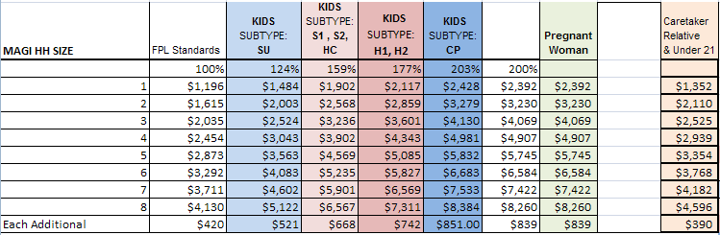
Did you choose CP? That is the correct SUBTYPE code. Debra’s countable income is $2900. The HH size is 2. $2900 is above the 177% standard but does not exceed the 203% standard. The code for 203% column is CP.

NOTE: When working production cases make sure to use the most current MAGI MIBW Subtype Worksheet located in the Manual MAGI Medicaid Toolkit.

Make the change to the SUBTYPE code on the MIBW – DO NOT CHANGE ANYTHING ELSE ON THE SCREEN –
<NEXT> to the MIAU
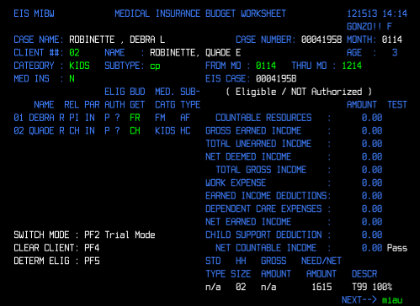
<ENTER> This will capture the CP code change
<ENTER> This will advance you to the MIAU screen
Check the SUBTYPE code to be sure it is correct, then AUTH the case with your PCN and assign the appropriate BENEFIT ISSUANCE Indicator (I – Immediate, or R – Regular) :
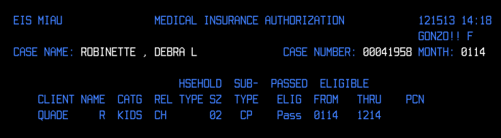

<ENTER>
Check to MED SUBTYPE on the MERE screen to ensure it is correct:

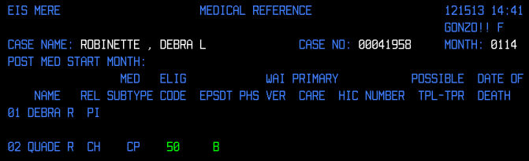
<ENTER>
Update the MERI if appropriate:
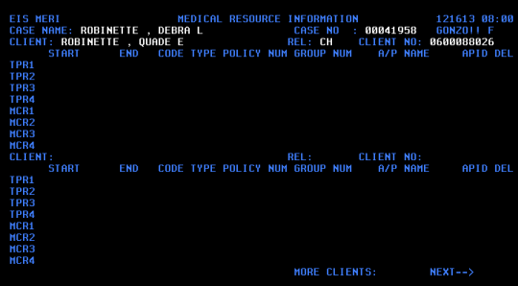

<ENTER>

Send the N011 notice that includes the macro verbiage developed by Policy and includes each individual’s name and the specific category they are eligible to receive.

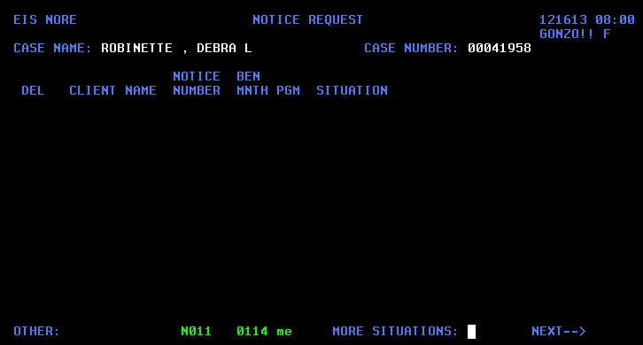

<NEXT> to the APEM and initialize this case into the current system month

Now this is important: You must go to any other open case (previously identified by printing a CLPM and CASS screen) and enter the correct INCOME information in both the MAGI application month and the current system month (if they are not the same) and re-authorize benefits on the FS or TA case. Once you have authorized benefits in the current system month be sure to check the CASS screen carefully and check the FSBH and/or TABH screens to ensure there has been no change to the benefit amount.

